Type | Defect report
ID | 01
Priority | Hight
Severity | Blocker
Created at | 03.01.2022
Affects Sprint | 01
Fix sprint | 01
Reporter | Sergey Polyakov
Application | Web (Chrome)
Status | Assigned
Assignee | Yurii Babay

Summary | The «404 Page not Found» error message is shown on the account page after user click Sing In
Requirement | Requirement ID 001
Environment | Prod
Reproducibility | Always

Description
Steps to reproduce:
1) Open wizzair.com
2) Click on “sign in” button in the right top corner
3) Fill “E-mail” and “password” fields and click “Sign in” button
Actual Result:
404 Page not Found
Expected Result:
Should be sing in to the account

Attachments:

Type | Defect report
ID | 02
Priority | Low
Severity | Major
Created at | 03.01.2022
Affects Sprint | 01
Fix sprint | 01
Reporter | Sergey Polyakov
Application | Web (Chrome)
Status | Assigned
Assignee | Yurii Babay

Summary | Incorrect encoding while creating agency account
Requirement | Requirement ID 001
Environment | Prod
Reproducibility | Always

Description
Steps to reproduce:
1) Open wizzair.com
2) Click on “sign in” button in the right top corner
3) Click on “agency login” button
4) Click on “registration” button next to “agency login” button
5) Click on dropdown language
Actual Result:
Name of languages should be correctness display
Expected Result:
Should be correct language encoding

Attachments: | 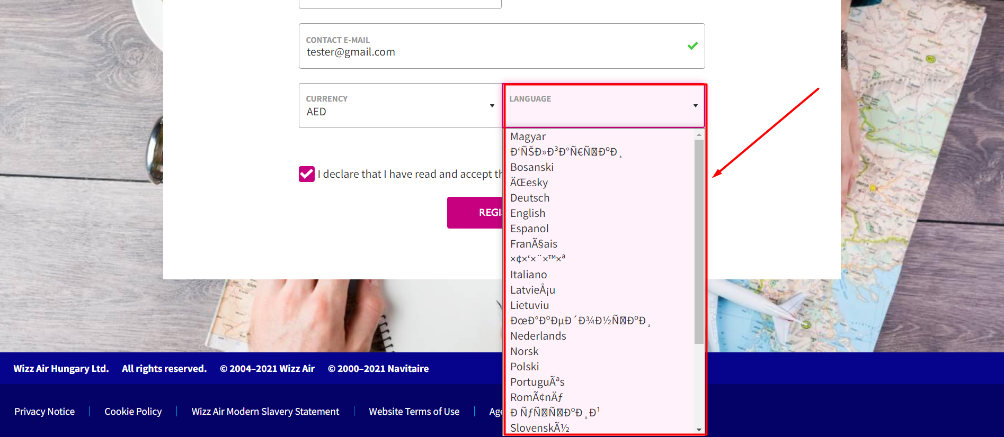
Type |  | Defect report
ID |  | 03
Priority |  | Low
Severity |  | Low
Created at |  | 03.01.2022
Affects Sprint |  | 01
Fix sprint |  | 01
Reporter |  | Sergey Polyakov
Application |  | Web (Chrome)
Status |  | Assigned
Assignee |  | Yurii Babay

Summary | Incorrect encoding while creating agency account
Requirement | Requirement ID 001
Environment | Prod
Reproducibility | Always

Description
Steps to reproduce:
1) Open wizzair.com
2) Click on “Information&Services” in the top menu
3) Choose “Current flight status” from menu Flight Status
4) Fill form By Airport “Origin” select a flight and “Destination” field leave empty and click ”Search”
Actual Result:
Error message is displayed with misspelled
Expected Result:
Should be correct displayed error message

Attachments: | 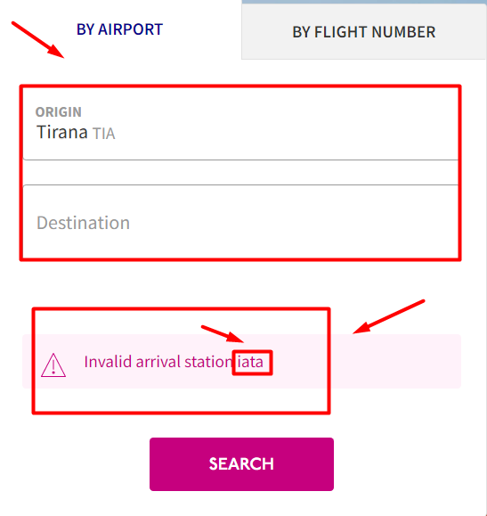
Type |  | Defect report
ID |  | 04
Priority |  | Medium
Severity |  | Critical
Created at |  | 03.01.2022
Affects Sprint |  | 01
Fix sprint |  | 01
Reporter |  | Sergey Polyakov
Application |  | Web (Chrome)
Status |  | Assigned
Assignee |  | Yurii Babay

Summary | Web page not found when user clicks on a link
Requirement | Requirement ID 001
Environment | Prod
Reproducibility | Always

Description
Steps to reproduce:
1) Open wizzair.com
2) Click on “Check-IN&Bookings” button in the right top corner
3) Fill “Confirmation code” and “Passenger’s last name” fields and click “Search” button
Actual Result:
Web page not found
Expected Result:
Should be opened page with user booking information

Attachments:

